Q1

The method that I used is box counting (Riemman Sum).

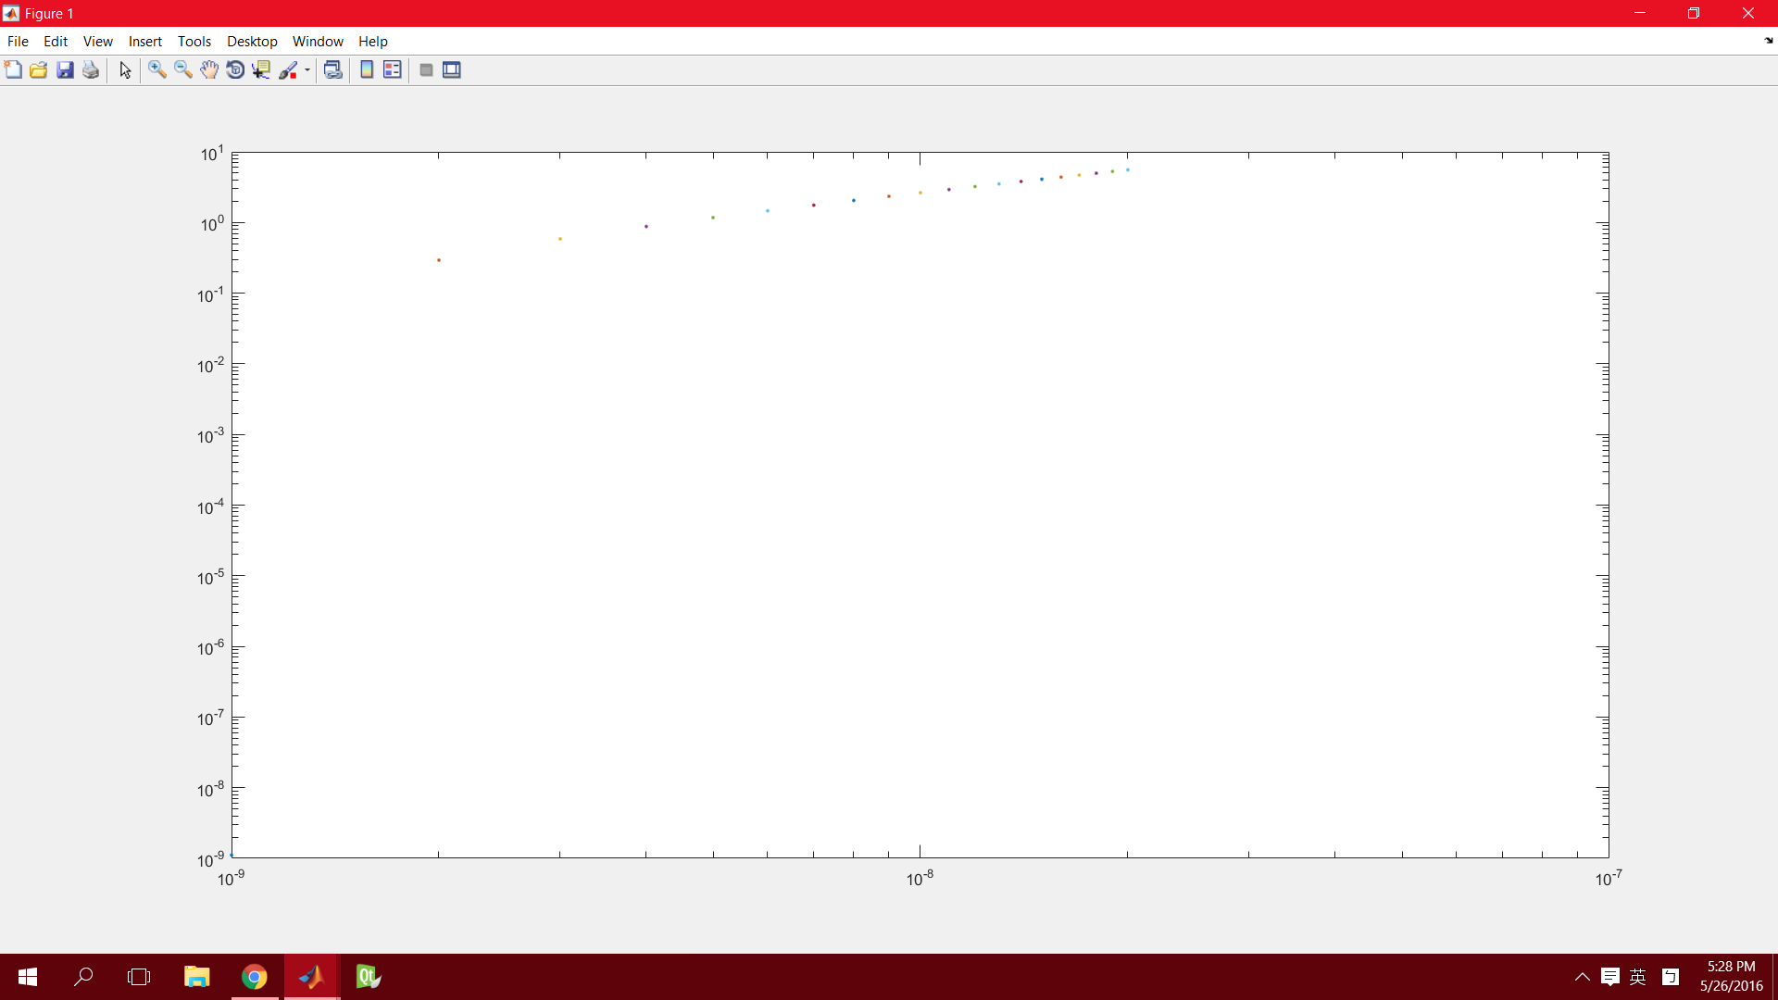

I tried h from 0.000000001 to 0.00000002 with the interval of 0.000000001:

And finally

H=0.00000001;

Q2

The method that I used is Trapezoid.

And finally

h=0.0000001;

Q3

2.513427e+01>>

2.514851e+01>>

2.512925e+01>>

2.513251e+01>>

2.514512e+01>>

2.514112e+01>>

The area roughly equal to 25.